**TASK 1**

**Objective:**

Write a C++ Program that contains four user defined function(s) plus(), minus(), multiply(), divide().

In main() function: Get two numbers from user. Call four user defined functions o Print the result from plus(), minus(), multiply(), divide(). In user defined functions: Plus and Minus function get two integer values and return integer. Multiply and Divide functions get two integer values and return float.

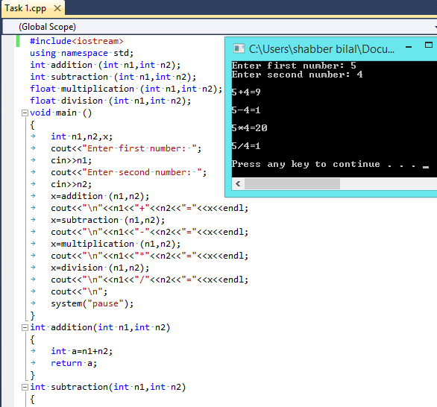

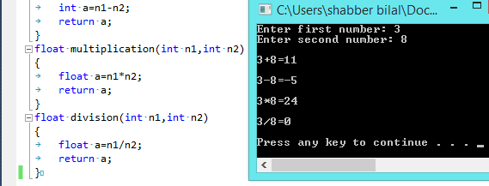

**TASK 2**

**Objective:**

Write a C++ Program that contains one user defined function cal_grades(). In main() function: Prompt user to enter obtained (0 - 100) marks for one subject. Call cal_grades(marks_subject). Print the corresponding Grade with respect to Marks. In user defined function: Perform conditioning with else if statement return char value. Function must return value.

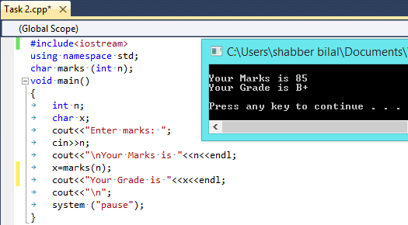

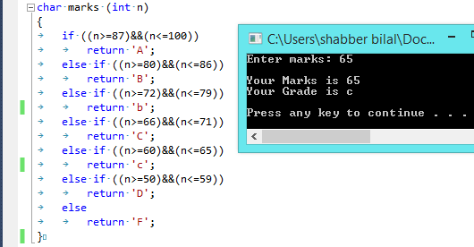

**TASK 3**

**Objective:**

Write a function that calculate factorial of any number given by user.Function return factorial.

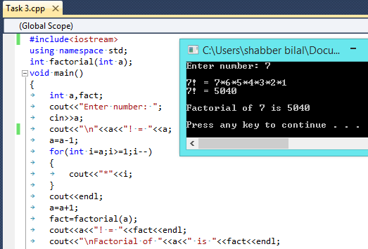

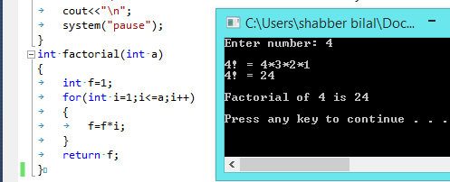

**TASK 4**

**Objective:**

Wtite a program that contain user define function Prime.This function checks whether the number is prime or not.The function must return value.In main print message **number is prime** for prime number and **number is not** prime if number is not a number prime.

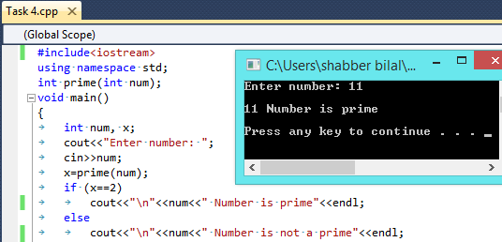

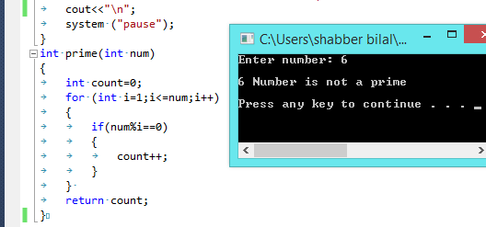

**TASK 5**

**Objective:**

Write a C++ that calculate the days since your birthday. Get three input from user(birth year, month and day). This program contains three user defined functions.

Cal_year_day() : get birth year and current year as parameter and return day difference. Assume that one year has 365 days. Return value is positive integer.

Cal_month_day() : get birth month and current month as parameter and return day difference. Assume that one year has 365 days. Return value is positive or negative integer.

Cal_day(): get birth day and current day as parameter and return day difference. Return value is positive or negative integer.

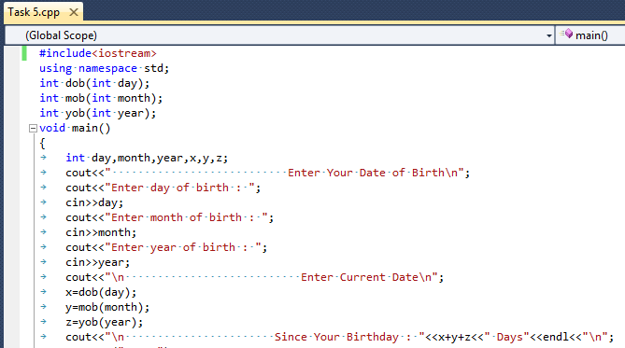

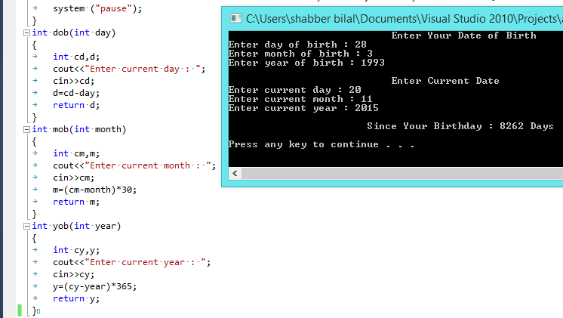

**TASK 6**

**Objective:**

Write a program that contains user defined function Salary.

In main input the following.

* Name of a person.
* Number of days in a week he works(in dollar)
* His hourly rate of work.

Assume that he works 8 hours in a day.

In Salary function.You have to calculate the salary of four weeks and return the salary(in dollar).

